Hi Sunny,

For this next chart, I am hoping to replicate a combination of what I saw online. I would like to replicate a chart with two subplots as seen below: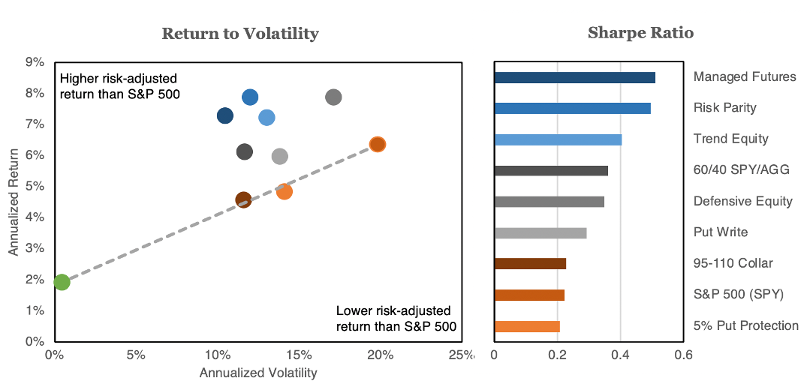

I have provided a CSV file that includes the data for graphing. Please see below representation of the CSV data and which graph each column is for: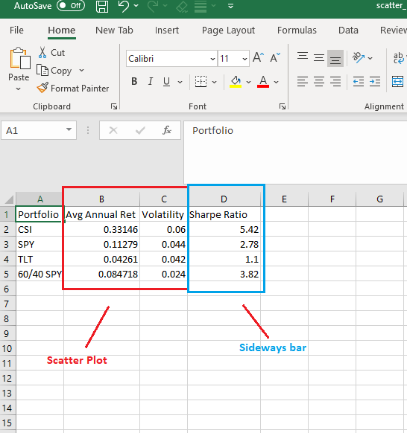

A notable features of the combo chart that I am trying to replicate… is the colors. I like how instead of a legend the viewer is able to figure out which dot on the scatter plot is by looking at the sideways bar.

The largest deviation from the example graph that I would like to make is shown below. Would it be possible to add grid lines to the scatter plot like the below example?